Dear Supplier/Contractor
I’m writing to share an update on Local Government Reorganisation across Lancashire.
This week marks an important step in the Government’s process, with the Ministry of Housing, Communities and Local Government announcing its preferred option for how local government will be organised in Lancashire.
Subject to Parliamentary approval, four new unitary authorities will be created across the county, to replace the current 15 councils.
This is the option the Government has chosen.
North - Lancaster, Preston, Ribble Valley  West - Fylde, Wyre, Blackpool  East - Blackburn with Darwen, Hyndburn, Rossendale, Pendle, Burnley  South - Chorley, South Ribble, West Lancashire | 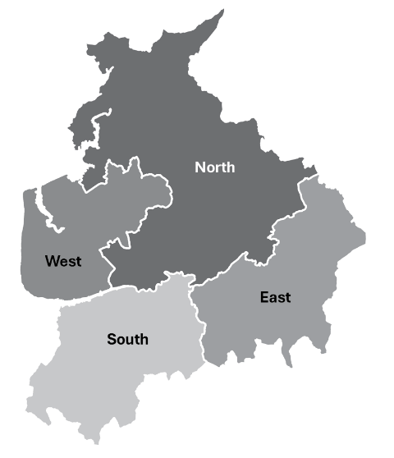
Councils across Lancashire will now continue to work together to plan the future structure of local government, including the transition to these new arrangements and the establishment of the new unitary councils in April 2028.
We recognise the important role our suppliers and contractors play in supporting the delivery of services for residents and communities.
At this stage, there are no immediate changes to existing arrangements. This means:
- Current contracts, agreements and payment processes remain unchanged
- Day-to-day commissioning and supplier engagement will continue as normal
- You should continue working with your usual council contacts

Our priority remains to ensure continuity of services while we plan for the future. As the programme progresses, we will provide further information about any changes that may affect suppliers, including future commissioning arrangements.

We are committed to keeping you informed and will share updates as more detail becomes available. [Include any opportunities for face –to-face engagement/events etc]
If you have any questions or would like to discuss this further, please do not hesitate to get in touch.
Thank you for your continued support and partnership.
Kind regards,
[Name]
[Title]

