Dear [Name],
Important update about local council changes in Lancashire
I’m writing to let you know about some changes to how local councils in Lancashire will be organised in the future.
The Government has announced its preferred option on how councils in the area will be restructured, subject to Parliamentary approval. This means that, in future, a smaller number of new councils (called ‘unitary authorities’) will be responsible for delivering local services. These new councils will take on the responsibilities that are currently shared across different organisations.
Below is a map showing how the new council areas are expected to be arranged.
North - Lancaster, Preston, Ribble Valley  West - Fylde, Wyre, Blackpool  East - Blackburn with Darwen, Hyndburn, Rossendale, Pendle, Burnley  South - Chorley, South Ribble, West Lancashire | 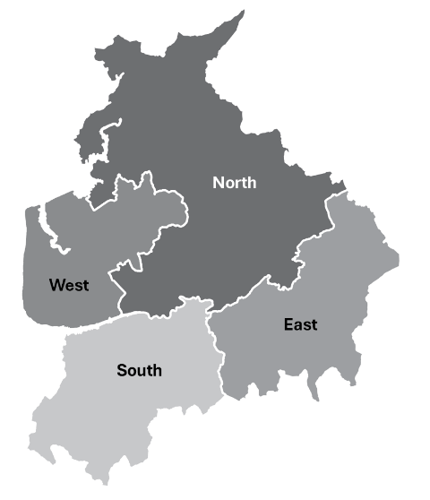

Local councils will work together to plan these changes and make sure the new arrangements are put in place smoothly.
There are no immediate changes to the services you receive. You should continue to access services in the same way. We remain focused on supporting you as usual.
We understand that changes like this can raise questions and we are committed to keeping you informed as more information becomes available.
There will be opportunities to find out more and ask questions as plans develop.
If you have any questions in the meantime, please feel free to get in touch.
Thank you for your understanding and continued support.
Kind regards,
[Name]
[Title]

