Thriving in Residential Care
March 2026

Title
Version number | 1.0
Document author(s) name and role title | Susan Shannon – Senior Quality Improvement Practitioner, Adam Croad, Julie Drummond and Karen Hodson – Contract Monitoring Officers.
Document owner name and role title | Susan Shannon - Susan Shannon – Senior Quality Improvement Practitioner.
Document approver name and role title | Sumaiya Sufi – Quality Improvement and Safety Specialist.

Date of creation |  | Review cycle
Last review | Jan 2026 | Next review date | March 2027

Version | Date | Section/Reference | Amendment

Introduction

This evaluation in January 2026 summarises the Lancashire Health & Residential Settings Contract Management & Quality Improvement Team project work, from June 2025 to promote Thriving in residential care and outlines plans for 2026.
The project became known as Drive to Thrive and focused on improving wellbeing, inclusion and quality of life for residents, families and staff across six key domains of thriving.

Background
Drive to Thrive in Lancashire is rooted in the findings of the My Home Life England research, which highlights six domains where older people can thrive in residential care: Relationally, Actively, Inclusively, Securely, With Dignity, and Healthily.
My Home Life England Research identified key areas where the care sector can celebrate and foster environments where residents experience personal growth, wellbeing, and meaningful engagement.
From these research findings, the following plan was developed.

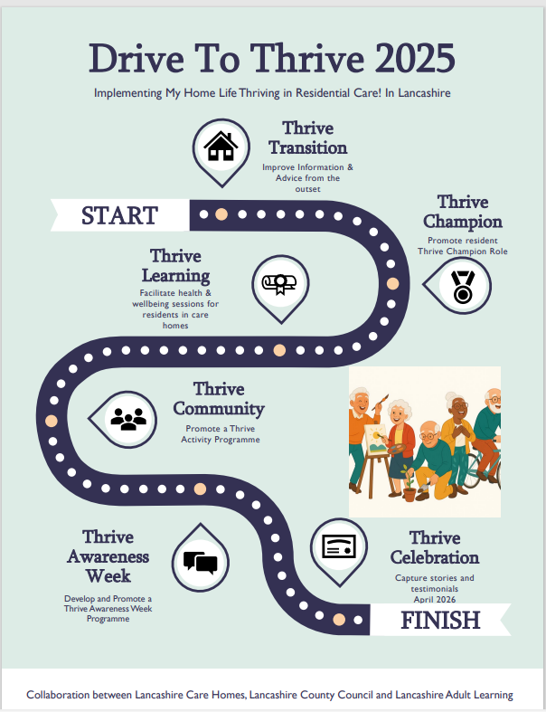

Drive to Thrive Key partners

Officers within the Health and Residential Settings, Contracts and Quality Team were encouraged to promote the Thrive project, leading to around 10 care homes expressing interest in promoting Drive to Thrive, becoming involved in developing resources and holding events.
Activity Forums across East, Central and North Lancashire provided peer support, shared resources and promoted the Thrive Champion role and Thrive resources to widen participation.
- Lancashire County Council Health & Residential Settings, Contracts & Quality Team
- Lancashire Adult Learning
- Andrew Smith House
- Springfield Manor Gardens
- Lancashire Activity Forums
- Other care homes consulted – Abbey Wood Lodge, Ashton Manor, Broadfield House, Brooklands House, Dercliffe, Favordale, Marsden Grange, McAuley Mount, Nelson Manor, We Care Group, Westwood Care Home.

Drive to Thrive Project aims in 2025

- Improve information available to people when transitioning into care
- Introduce Thrive Champion roles
- Deliver accessible Thrive training
- Promote Thrive Activity/Awareness Weeks

Improve Information for Transition into Residential Care Placement
Meetings with Care Finding Team to explore how Lancashire County Council can strengthen the quality and clarity of information shared during placement decisions.

Introduce Thrive Champion Role
A Thrive Champion Pack was developed and distributed via Lancashire Care Home Activity Forums. This resource supports staff and residents nominate a champion, with guidance on embedding Thrive principles.

Deliver accessible Thrive Training in Care Homes
Lancashire Adult Learning delivered Thrive themed wellbeing training in three Lancashire care homes, 6 sessions in each care home were arranged, attended by residents, family members and staff. These sessions were also available to the public. Training themes included mindfulness, confidence-building and health-based activities.

Develop and promote a Thrive Activity Week
A Drive to Thrive Activity Week programme was developed and distributed via Lancashire Care Home Activity Forums. The resource promotes including arts sessions, music, mindfulness, gentle exercise and reminiscence work. With ideas for activities, the inclusion of residents, staff and families, and a format for evidence gathering for CQC requirements.

Mid-Way Evaluation & Learning

- Drive to Thrive has strong interest but requires hands-on support to implement
- Training is impactful
- Barriers to take up (All – misunderstanding of what Thrive project involves. Staff - staffing pressures, competing priorities and capacity issues. Resident pressures - mobility, paperwork demands,)
- Importance of adapting learning requirements for residents. Adult Learning programmes require evidence of learning for Ofsted and funding purposes, which limits rolling out programme delivery.
- Peer activity forums are a strength for spreading practice

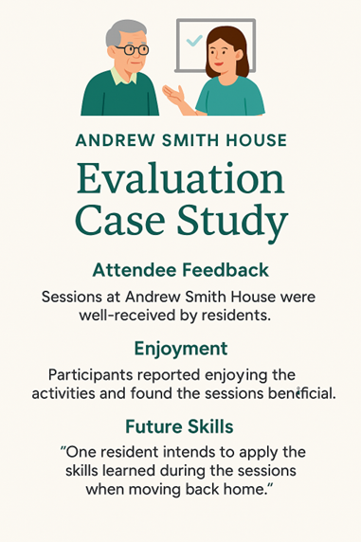
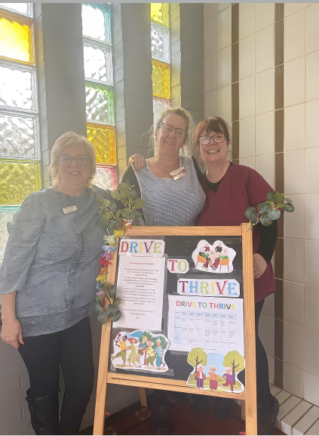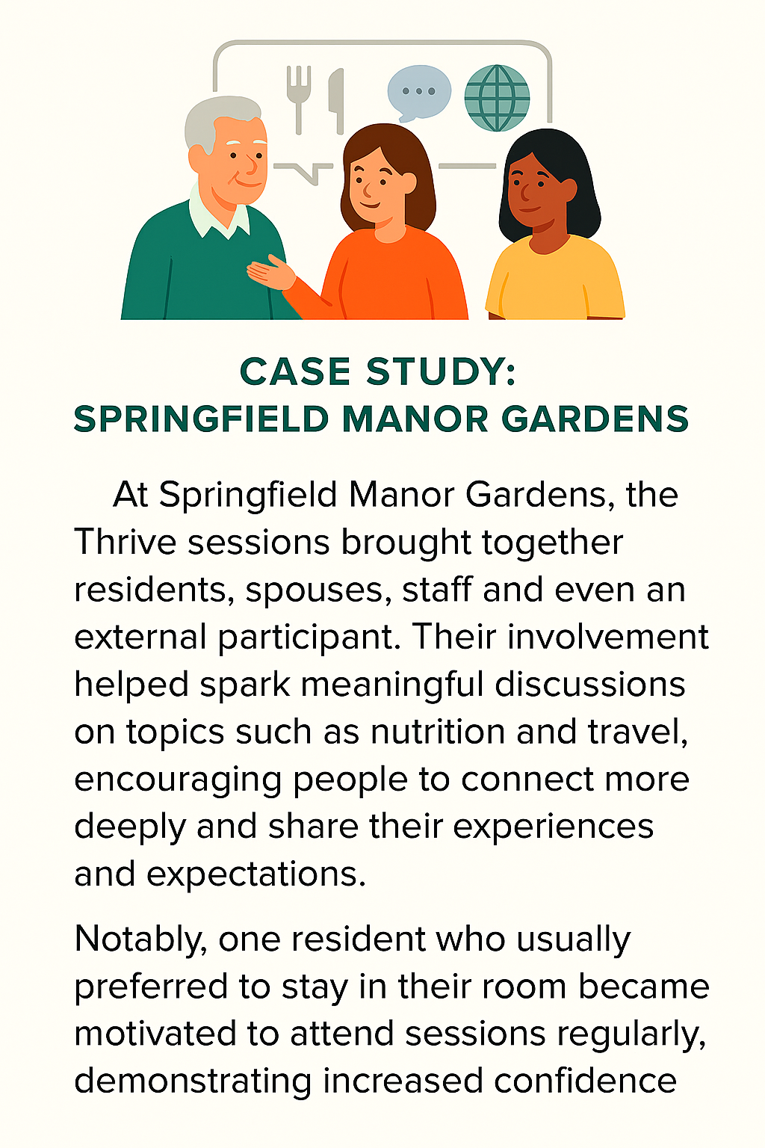
Drive to Thrive Activity Week at Brooklands House.

Plans for 2026

Thrive Music Initiative
In January 2026, a Thrive ‘Music Through the Ages’ resource was developed to support music focused Thrive opportunities. Activities are themed by decade and include reminiscence, movement and colour themes. The programme will be shared via Lancashire Activity Forums in 2026.

Thrive Activity Volunteers
In Spring 2026 we will be linking in with Lancashire Adult Learning, to explore how 16–19-year-old students can be offered volunteer placements within Accrington, Burnley Pendle & Rossendale based Care Homes to implement a Thrive Activity/Awareness week and the Thrive Champion role.

Thrive Celebration Event
In April 2026 we plan to deliver a short presentation on Thrive, with the aim of sharing learning from the project with care home managers, promoting the Thrive resources developed, and increasing the learning from Thrive research, with a continued commitment to inclusive practice.

Thrive Train the Trainer
Lancashire Adult Learning to consult with curriculum team to determine the feasibility and fit of a train-the-trainer programme for activities coordinators. This would potentially introduce mindfulness, confidence-building and health and well-being-based activities, more routinely into care home activity programs.

Thrive Theatre
We will explore opportunities for local schools and college drama groups to collaborate with care homes on an interactive play. The aim is to foster intergenerational connections and highlight what it means to thrive in care homes for residents, staff, and students.

Thrive Activities
We will continue to focus on growing the membership of the activity forums that take place in Central, East and North Lancashire to build on the strength of peer forums, to promote and embed Drive to Thrive.

Conclusion

The Drive to Thrive project has the potential to make a real difference in Lancashire care homes, with residents, families, and staff benefiting from new opportunities to connect, learn, and feel included. There’s genuine enthusiasm for the initiative, and the training and peer support help build momentum. Of course, there are challenges—like time pressures and the need to tailor activities to individual needs—but the commitment to continuous improvement and improving life in residential care is clear. With fresh ideas on the horizon, the future looks positive for embedding Thrive principles.

Thrive Resources produced for Care Homes during the project

Introduction to Thriving in Residential Care PowerPoint

Thriving Quality Assessment Framework
Drive to Thrive Week Plan – including champion role outline
Back in Time Thriving with Music

