The applicant believes the ‘tilted balance test’ should be engaged due to the fact that the Lancashire Minerals and Waste Core Strategy and Minerals and Waste Local Plan are out of date [Proof of Evidence of Liam Toland BA, pages 6-8].
However, Lancashire County Council does not rely on these policies in their refusal of the application. Indeed, LCC state they carry ‘little weight’ [Statement of Case of Lancashire County Council, para 6.3] apart from policy CS5 of the Core Strategy and policies DM1 and DM2 of the Local Plan, which are considered to be relevant and should carry full weight as they deal with the assessment of environmental impacts and accord with national policy.
Thus we do not believe the Tilted Balance Test should be engaged.
Should the Tilted Balance Test be engaged, permission should be granted unless "specific policies in [the] Framework [NPPF] indicate that development should be restricted" (e.g., in Green Belts, AONBs, or Sites of Special Scientific Interest) but it is not automatic. There must be a balance - weighing the principle against environmental impacts, including noise and dust pollution.
The "tilted" balance shifts the focus to whether impact from the operation is so excessive it meets the high threshold of "significantly and demonstrably" outweighing the benefits, rather than just merely being disruptive.
LCC calls the impact of noise on the closest residents ‘unacceptable’ [Statement of Case of Lancashire County Council, para 7.4] and in our evidence on noise we provide more information that proves this is the case and outweighs any general (and disproved) ‘need’.
Our main points are as follows:
- The area is tranquil.
Environmental Sensitivity is important: In quieter rural areas, lower noise limits are appropriate where the 55dB(A) maximum exceeds the existing background level by more than 10dB(A).
As we can see from the developer’s own figures [see table 4 below] the noise limit of 55dB(A) is higher than 10dB(A) more than the background noise at 10 out of 12 properties where sound was measured. [Noise Assessment. Proposed Mineral Extraction and Restoration, Land off Bourbles Lane, Preesall, Lancashire, GREENFIELD ENVIRONMENTAL, 2023, table 4 page 17]. With background noise between 37 and 42dB(A) in 10 out of 12 properties there is an argument that this is an area of tranquility whose tranquil nature needs to be protected and enhanced. [see https://www.gov.uk/guidance/noise--2].
- Ambient noise levels mean lower (category A according to BS 5228) noise levels should be used.
In any case we believe that the developer should be limited to category A noise levels in BS 5228 [page 119 – see Table A below]
Table 4 from developer’s materials:
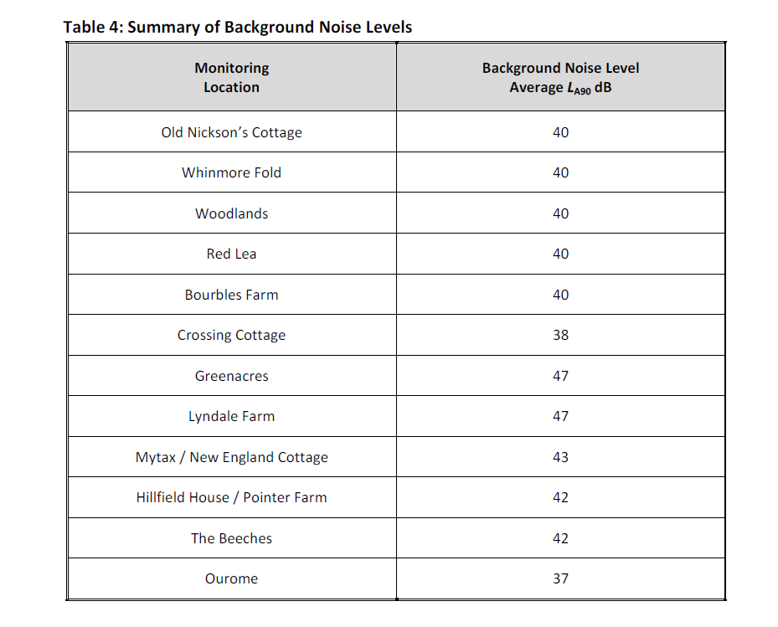
Table A from BS 5228 [page 119]
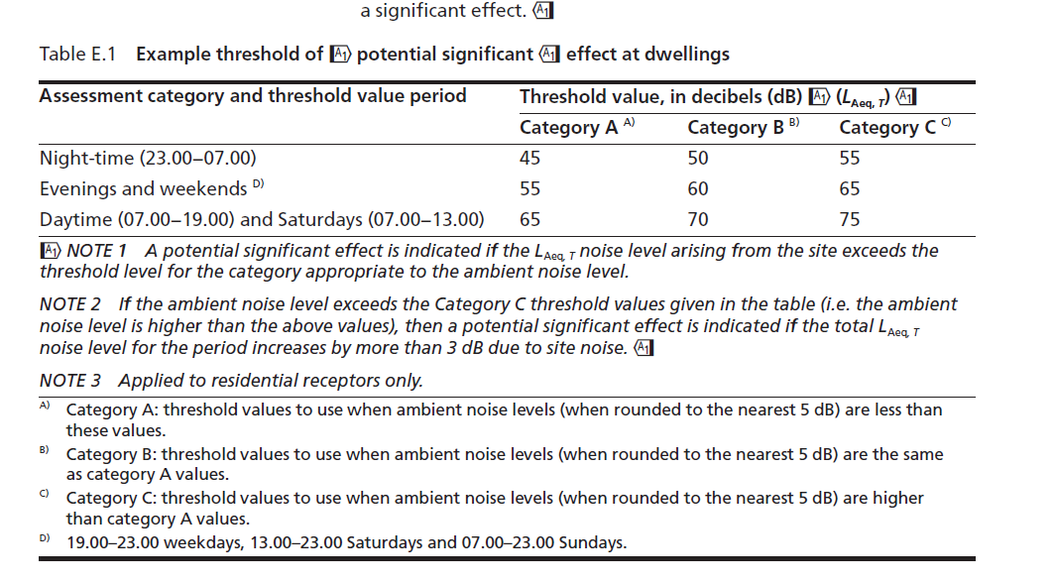
As table A shows above where ambient values are the same as the category A values (rounded to the nearest 5dB), category B levels should be used. However, the noise levels rounded to the nearest 5dB is lower than the category A levels so these should be used throughout – meaning the highest noise level allowed should be 65dB during the day time NOT 70dB.
- The noise from heavy machinery at the top of huge stockpiles right next to residential properties has not been taken into account
There has been no calculation or consideration at all of the noise from machinery working at the top of 10m high stockpiles which are less than 100m from two residential properties (Mytax and New England Cottage).
- Gap in bunds at 3a and 3b extraction phases
New England cottage and Mytax will again suffer in particular during between 3a and 3b extraction phases as there is a gap in bunds. Bunds are v shaped so same two properties will be in the direct line of noise with no mitigation.
- Phase A – quarrying is not preparatory work and the new ‘temporary barrier’ has no details at all
Until recently the applicant planned to quarry from the phase A area and then fill in the hole as ‘foundations’ for the bunds for phase 1. This would have meant no protection at all for residents and we believe that as the quarrying did not mean laying any meaningful foundation for the bunds – and indeed only stretches halfway across them - should not be allowed.
The applicant has now introduced a ‘temporary barrier’ until the bund is in place, but it is not included in any drawings, there is no information on what it is, what it is made of or its height. As Woodlands is only 90m away and Red Lea 125m away [ PROOF OF EVIDENCE OF ROBERT STOREY, page 14] this is not acceptable.
- The design has changed and there has been no re-calculation of the noise or visual impact
The applicant has submitted that the bunds are not high enough. Phase 4 bunds in particular need to be 1.5m higher. The impact of this on residents needs to be recalculated.

