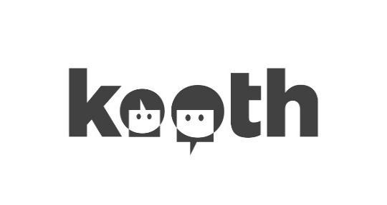

Dear Parents & Carers,
Your child may have mentioned they have been made aware in school of a service called Kooth, commissioned by the CCG
Kooth is a Free, Anonymous and Safe Online Mental Wellbeing Community for young people aged 10-16 within the local area.
We provide a range of services to support young people’s wellbeing. Our trained and qualified counsellors are available until 10pm each night, 365 days per year. We also host pre-moderated, age appropriate peer to peer discussion boards, live forums and articles all of which hold young person friendly information as well as therapeutic content.
Whilst your child may not need or use the service, as part of supporting our schools to support students to look after their wellbeing, we are ensuring all children are aware of provision in the area that could assist them now, in their transition to secondary school or in the future.
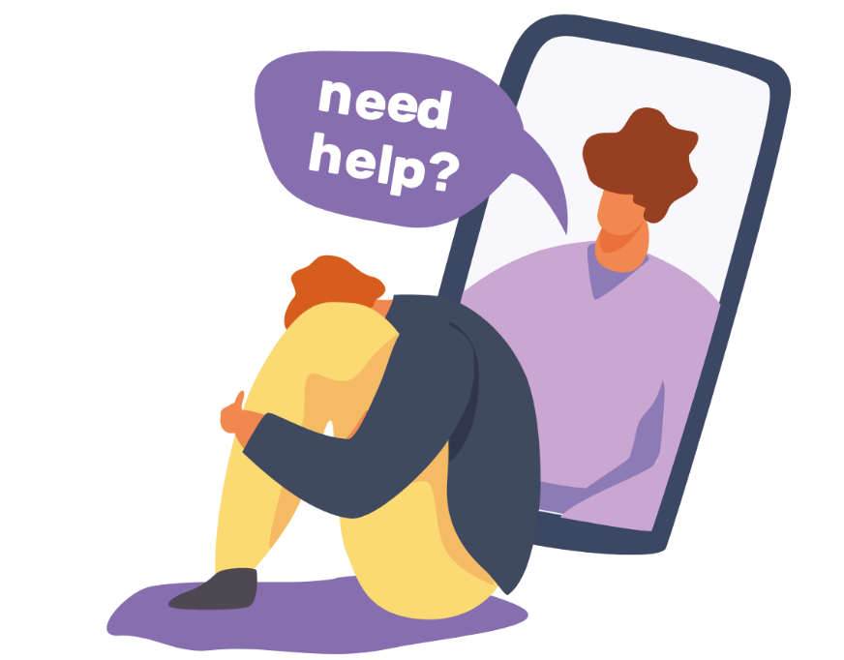
If you have any questions or would like to discuss what Kooth can offer, please speak to (insert named person at school) who will be able to answer your queries. If you would prefer to speak to representatives from Kooth directly, please email the Kooth team on parents@xenzone.com

Kind Regards

Heather Hook
Engagement Lead for Cumbria

(Insert Name of area covered by worker)

