Arthur Edmondson Quinn Scholarship
Guidance Notes
Academic Years 2019 - 2021
Deadline for submission: 26/07/2019

Deadline for applications is 26 July 2019 at 5.00pm
Applications can be made for travel to take place in either the 2019/20 or 2020/21 academic year.

About the Scholarship
The purpose of the scholarship is to provide the opportunity for young people aged 16 – 25 to expand and further their educational knowledge through the purpose of travel.
This scholarship was established by the Will of the late Mr Arthur Edmondson Quinn of Great Harwood (and previously of Padiham), who bequeathed a one-fifth share of his residuary estate, upon a Trust, to Lancashire County Council for the purpose of establishing a Travel Scholarship. This scholarship is designed to provide an opportunity for 16-25 year olds, in full time education whose parents live within the boundaries of the former Urban District of Padiham and who normally reside there during vacation, to travel abroad to expand their education.

Please read the following guidance carefully to check that you are eligible.

Who can apply?

You must meet the following criteria to be eligible to apply:

- Individuals aged between 16-25.
- Must be in full time education.
- Whose parents live within the boundaries of the former Urban District of Padiham and who normally reside there during vacation.
- Who for financial reasons would not in the said opinion of the County Council have the opportunity for overseas travel.

If you meet the above criteria, then you are eligible to apply for the Arthur Edmondson Quinn Scholarship.
Applicants under the age of 18 are required to travel with a parent, guardian or a responsible adult. The accompanying adult must make their own financial arrangements to travel.
A map of the old urban district of Padiham is attached to the back of this document for reference.
If you are unsure whether your application is eligible, please contact the team to discuss further.

Please note just because your application meets the eligibility criteria does not mean that you will automatically be awarded funds. Your application will be assessed by Democratic Service officers, and eligible applications will be determined by the Trustees of the scholarship.

Please note:

- Successful applicants must ensure they obtain travel insurance before the trip takes place, if documentary evidence of this is not provided at least 1 month before the travel date, Lancashire County Council obtains the right to withdraw any offer of funding.
- All individuals should be aware that, if required, they must provide a copy of their valid passport to Lancashire County Council on submission of their application. If you currently do not have one, a valid passport must be obtained and a copy of the passport provided to Lancashire County Council before the trip commences, if successful.
- Applicants should be aware that when submitting their application, we require evidence of each item of the breakdown along with an itinerary for the trip.

Funding
We expect that most applications for funding will fall within a range of £500 - £3,000. However, this is a guide only, and Trustees may consider granting more or less to an applicant based on merit and individual circumstances and the type of educational visit they wish to go on.
We will not be able to fund the same project again in subsequent years, unless you are able to demonstrate how it adds value to your developing education.
The scholarship cannot be used retrospectively, all travel arrangements must be for a future date.
A valid bank account statement (from within the last 3 months) for the applicant is required on submission of the application.

How will my application be assessed?

Your application will be assessed to ensure it meets the criteria and the objective of the scholarship by officers at Lancashire County Council who will check that the application is eligible for the scholarship using the criteria detailed in this guidance.

Eligible applications will then be considered by the Trustees of the scholarship, who are elected County Councillors who serve the area of Padiham and the surrounding areas. The Trustees will determine which applications will be funded and for how much.

How to apply?
- Check that you meet the eligibility criteria. If you require any further information, or are unsure if you are eligible please contact the team.

- Decide when and where you would like to visit and the amount of funding you require. We request that you look around for the best value for your trip and consider a number of options.

- Please either download and complete the application form OR alternatively you can request a form to be sent to you by the team (contact details can be found at the end of these guidance notes).

- Please complete the entire application. The application is split into 3 sections, all sections must be completed for your application to be considered, unless you are above the age of 18 in which only the first and the last section must be completed. The application consists of three parts: applicant's section in parts 1-5, a parent/guardian's section in part 6 and 7 which must be completed if applicants are under the age of 18, and an academic tutor section at part 8 which must be completed for all applicants. We also will require a complete breakdown of how much you wish to spend and supporting evidence of each item you wish to include.

- Once you have your completed application, ensure that all the required declarations are signed, the first by yourself, the second, if you are under the age of 18 by a parent/guardian and the third by your tutor.

- Please note if you require a valid passport for your travel, we will require you to provide your passport details and a copy of your passport along with your application.

- We also require sight of a recent (last 3 months) bank statement for us to pay the successful applicant.

We require a hardcopy of all signatures to be sent to us, either through the post or by being signed, scanned and emailed to us along with your application.

Please note we will not be able to process your application without the signed declaration forms.

- The completed application form and the additional documentation requested (see the checklist at the end of the form) will need to be sent to Democratic Services for consideration. Contact details are provided at the end of the guidance notes.

- Your application will then be checked against the eligibility criteria to determine the suitability of your application.

- Eligible applications will be considered by the Trustees of the scholarship who will determine which applications will be awarded funds.

- Once the Trustees have decided who the successful applicants are, applicants will be informed by email.

- We will require sight of valid travel insurance documents at least 1 month before your travel date. The travel insurance must cover as a minimum:
- Medical Emergencies
- Personal Accident
- Personal Liability
If you fail to provide this we reserve the right to withdraw your application and not proceed further with it.

- If for any reason you need to make changes to your travel arrangements due to unforeseen circumstances you will need to inform us beforehand.

Monitoring and Evaluation
Financial

If your application is successful, along with your offer letter we will send a monitoring form to you. We require you to complete and submit this along with copies of receipts/ invoices for the full amount of the grant, within 3 months of your return.

Publicity

Lancashire County Council may wish to publicise grants awarded from the Arthur Edmondson Quinn Scholarship. As a condition of the grant, Lancashire County Council reserves the right to publicise the applicant's travel arrangements etc. in the local media. If the applicant or the educational establishment intends to publicise the success of the scholarship themselves, they are required to inform Lancashire County Council using the contact details provided at the end of this application.

Lancashire County Council may request you to provide any photographs etc. to help publicise the success of the grant.

Declaration

The declaration you/ your parent/guardian and your tutor sign on your application form makes it clear that you are stating the truth and agreeing to the terms and conditions set out in the declaration. It is a signed agreement which holds you responsible to spend the grant money as you have said you would. Please be aware that we hold you to this declaration and if you are unable to spend the money on the travel arrangements as stated, you must inform us of any changes and we will decide if your new project meets the relevant criteria. Lancashire County Council reserves the right to reject, withhold or withdraw any application or financial funding in line with the grant, if it is found that the money will not be spend on the stated travel plans. Lancashire County Council may also require you to return all or part of the grant if it is not used in accordance with your application unless changes have been notified and agreed in advance.

We require you to return any unspent monies awarded to you in respect of your travel arrangement.

Can I provide feedback?

The County Council is committed to continuous service improvement and we welcome any feedback. If you would like to give feedback please contact the team.

Deadlines
The deadline for applications is 26/07/2019
Please note that the money must be spent by the end of September 2021.

IMPORTANT - We will always acknowledge receipt of your application, if you have not heard from us within 48 hours of submitting your application form please get in touch to ensure we have received your application. We cannot be held responsible if we have not received your application either via email or post.

Contact Details

Telephone: 01772 530818

Email: Misbah.Mahmood@lancashire.gov.uk

Postal Address:
Misbah Mahmood
Arthur Edmondson Quinn Scholarship
Lancashire County Council
Legal and Democratic Services
2nd Floor, Christ Church Precinct
County Hall
Preston
PR1 8XJ

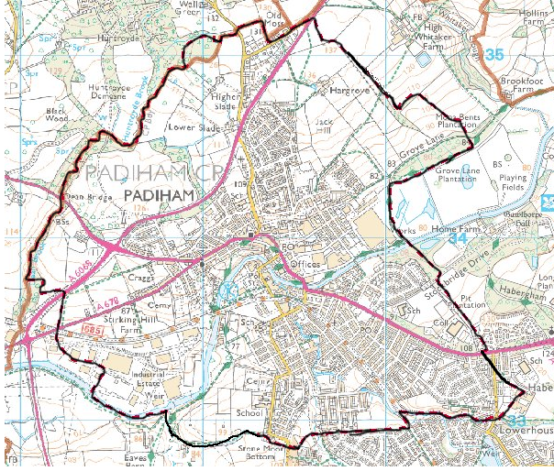
Map of Old Urban District of Padiham
© Crown Copyright. All rights reserved. Lancashire County Council Licence 100023320, 2011
Arthur Edmondson Quinn Scholarship Fund Guidance Notes 2019/21

