
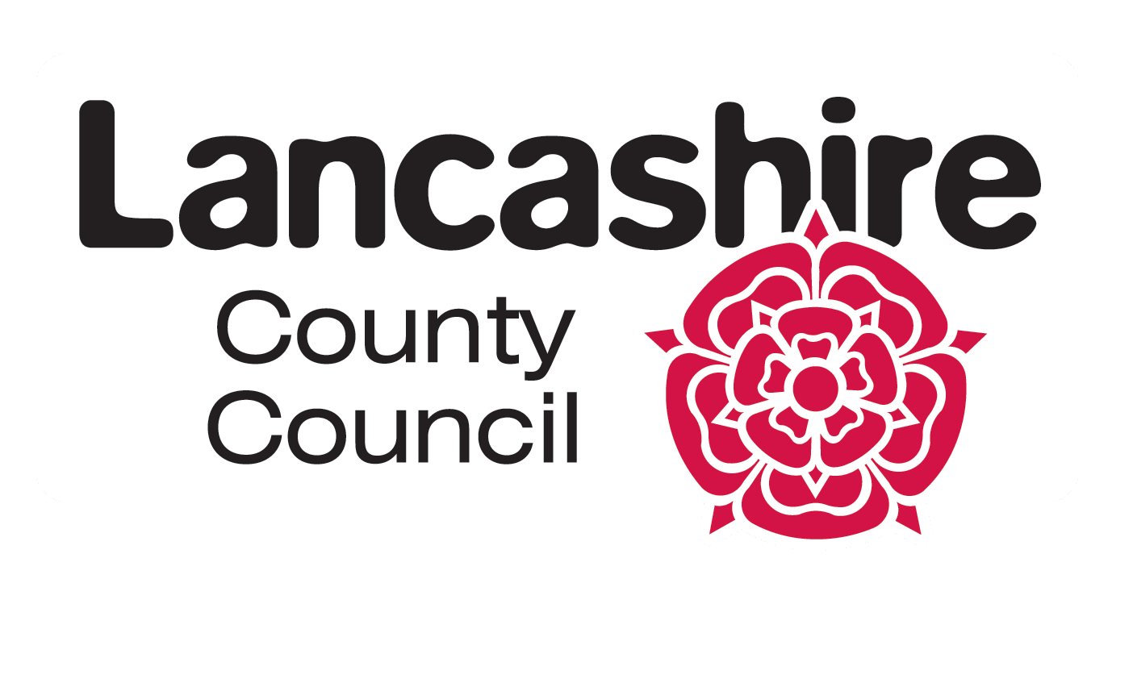

CHILDREN SOCIAL CARE Complaints
Annual Information based on Quarterly Data 1st April 2017 – 30th April 2018…

Children's Complaints and Compliments

1st Quarter 1 April 2017 – 30 June 2017

A total of 88 complaints, of which 30 were non statutory, were received in the 1st quarter 2017/18. This figure remains steady when compared to the 4th quarter of last year (89), but when compared with the same quarter of the previous year (79) it is just over an 11% rise in the total number received this quarter.

Of the 88 complaints received, 35 were dealt with at Stage 0 and 52 moved on to investigation at Stage 1, with 1 currently open at stage 2. Just over 46% of the complaints received were also closed within this quarter which is a continuing improvement when comparing with the previous quarters. Social Work Practice was the most reported service type this quarter with 45% reported under this category.
6 LGO final decisions were made, of which 1 was upheld, the LGO felt the Council did not ensure the Child's Occupational Therapy assessment had considered the child's current needs and the Council has agreed actions to remedy injustice caused by this fault and prevent its reoccurrence.
Of the other 4 final decisions, 1 had early resolution and the other 4 were not investigated.

Internal Learning:
- Service User advised that own consent forms can be signed with regards to attending a Linx group.
- When staffing issues necessitate a change in allocated Case Worker or Social Worker, an explanation is provided to young people, dependent on their ages and understanding, explaining the reasons why.
- The method of dealing with certain situations will be looked at with social workers to look at how information is shared in future.
- Acknowledged that improvements are needed in order for the service to be accessed easier than at present.
- The importance of seeking prompt medical advice will be instilled into the Management team.
- Medication Alerts will be sent to all establishments to remind staff that it is important to administer the first dose of antibiotic upon receipt of them unless the Prescriber has instructed otherwise.
External Learning from upheld LGO cases:
- To ensure staff continually go through refresher training and look at the automatic eligibility criteria system and find ways to improve this

*The term Statutory is where the complaint is made by a person who can complain under the statutory procedures
A total of 20 compliments were received this quarter which is a small decrease when compared with the previous quarter (28). However it is a significant increase when comparing the same quarter of the previous year (12).

Children's Complaints and Compliments

2nd Quarter 1 July 2017 – 30 September 2017

A total of 20 compliments were received this quarter and an example of a compliment received in this quarter is: 'Thanks for all your hard work. I have been really impressed by the depth and level of detail in the work that you've undertaken' - Family Support Worker, Children's Social Care.

A total of 77 complaints, of which 20 were non statutory, were received in the 2nd quarter 2017/18. This figure is a reduction of just over 12% when compared to the 1st quarter of this year (88) and less than the same quarter of the previous year (84).

Of the77 complaints received, 38 were dealt with at Stage 0 and 39 moved on to investigation at Stage 1. Almost 44% of the complaints received, were also closed within this quarter. Social Work Practice continues to be the most reported service type this quarter with 35% reported under this category.
5 LGO final decisions were made, of which 2 were upheld, the LGO has recommended several changes to policies, procedures and practices to ensure we investigate complaints in a timely manner, improve our communication and partnership working with servicer users, carers and families and feedback on learning from complaints.
The other 3 final decisions were not investigated.

Internal Learning:
- Where staffing issues necessitate a change in the allocated worker, an explanation should be provided to young people, dependent on their age/understanding, explaining the reasons why.
- For Young People to receive copies of any assessment that relates to their personal circumstances dependent on their ages and understanding.
- Young people are to be invited to Core Groups and Child Protection Conferences and for a note to be placed on the Young Person's Case File to confirm this.

External Learning from upheld LGO cases:
- Signpost relevant customers to benefits advice and provide support for them to apply for DLA/PiP and any other benefits to which they might be entitled.

Children's Complaints and Compliments

3rd Quarter 1 October 2017 – 31 December 2017

A total of 50 compliments were received this quarter and an example of a compliment received in this quarter is: The young person felt very supported by the social worker and felt confident that she had a good understanding of how the young person felt and what she hopes to achieve. The Guardian commented on the social workers child centred approach and how encouraging it was to speak to a young person who had developed a meaningful and genuine relationship with their social worker.' - Support Worker, Children's Social Care.

A total of 78 complaints, of which 10 were non statutory, were received in the 3rd quarter 2017/18. This figure is a similar number when compared to the 2nd quarter of this year (77) and similar to the same quarter of the previous year (76).

Of the78 complaints received, 51 were dealt with at Stage 0 and 27 moved on to investigation at Stage 1. 74% of the 78 complaints received were completed within this quarter. Social Work Practice continues to be the most reported service type, with 28% of complaints under this category.
4 LGO final decisions were made, of which 1 was not upheld and the other 3 were not investigated.

Internal Learning:
- Gave apology for general oversight of information being shared when it should have remained anonymous.
- Independent Reviewing Officer (IRO) reminded they do need to speak directly to all professionals during meetings.
- Consideration will be given to allocation of a different Leaving Care worker, if this is in line with services users wishes.
- Case re-allocated to a Senior Social Worker with better understanding of case.
- Professionals meeting to be held to discuss the issues around the Educational Health Care Plan (ECHP)

A total of 99 complaints, of which 23 were non statutory, were received in the 4th quarter 2017/18. This figure is almost a 27% increase when compared to the 3rd quarter of this year (78) and a slight increase when compared to the same quarter of the previous year (89). Of the 99 complaints received, 65 were resolved at Stage 0 and 34 moved on to investigation at Stage 1. 61% of the 99 complaints received were responded to and completed within this quarter. Social Work Practice continues to be the most reported service type, with 48% of complaints under this category
8 LGO final decisions were made this quarter, of which 3 were upheld, 1 was not upheld and 4 were not investigated.

Internal Learning:
- Gave apology for the difficulties that arose from the meeting at the contact centre. Informed the complainant that the contact centre have been spoken with re this matter to hopefully avoid similar situations in future.
- Assured the complainant that the social worker has been spoken to in relation to cancelling meetings.
- Social Care team to be spoken to as part of development and learning to ensure that staff communicate effectively.
External Learning:
- Ensure sure staff in service areas who deal with children are aware of the requirements of Getting the Best from Complaints 2006 in dealing with complaints by or for children.

Compliments
A total of 40 compliments were received this quarter.
An example of a compliment received in this quarter is: .I would like to express my gratitude to the caseworker who has been very supportive throughout this long journey that we have been on. The caseworker has offered sound advice and I genuinely feel that he understood our predicament, he has done nothing but be positive and I can tell he is absolutely dedicated to the children and families he works with. I always felt listened to and informed as a parent in a truly and sometimes traumatic situation.' - Support Worker, Children's Social Care SEND.

Summary of Complaints/Compliments

Complaints/Compliments 2017 - 2018 | Q1 | Q2 | Q3 | Q4 | Total
Statutory and Non- Statutory Complaints | 88 | 77 | 78 | 99 | 342
Compliments | 20 | 50 | 50 | 40 | 160

